RS 400 for sale

Description
RS400 1092 for Sale -£2,500
This boat has always been lake sailed apart from a couple of Championship events.
I have had it from new and have added many upgrades. I have replaced most of the ropes bar the wing wang lines, upgraded to continuous control lines and added a new kicker system.
It has a reasonable set of sails which are suitable for club sailing plus a variety of older sails.
It sits on a Combi / Trailer. A breathable top cover is worn but the nylon undercover is good.
Boat is currently lying at Grafham Water Sailing Club.

Specifications
Builder: | RS
Make: | RS
Model: | 400
Constructed: | 2001
Sail number: | 1092
Length over all: | 4.52m
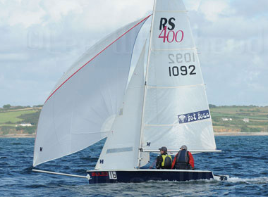

Alan Cooke
alancooke_uk@yahoo.co.uk
Tel 07900262129

